Name : Jhon Brix Brion

Section : CCS 1F

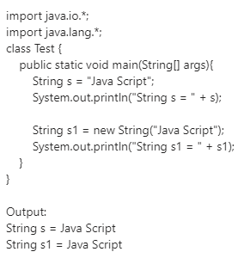Subject : CC3 Lecture

In the Line 5th line where “String s = “Java Script”;” is an object declared by the user to create an object inside the String Pool, wherein the String Pool is inside the Heap memory. If we create multiple objects with the same value, it will never create a new Object inside the String pool, but it will use the first object made by the first object the user has declared as it’s reference object inside the String pool. This way the code will use less memory in the Heap Space to be allocated

The 7th Line where “String s1 = new String(“Java Script”);” is also an object declared by the user to create an object inside the String Pool. but it this time, it creates a separate object inside the String Pool and allocates a memory to it. If we create multiple Objects with the same value, in this case it creates a different object in the String pool, it will create a new Objects inside the String Pool depending on how many Objects that we created.

2.  
Code

import java.io.\*;

import java.lang.\*;

public class JavaActivity2

{

public static void main(String[] args)

{

String edition1 = "Minecraft Java Edition";

System.out.println("Edition = " + edition1);

String edition2 = new String("Minecraft Java Edition");

System.out.println(" Edition = " + edition2);

String edition3 = "Minecraft Java Edition";

System.out.println(" Edition = " + edition3);

System.out.println(edition1 == edition2);

System.out.println(edition1 == edition3);

}  
}  
Output :  
